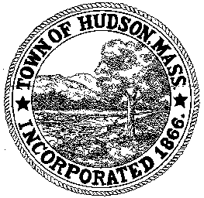

CONSERVATION COMMISSION
78 Main Street, Hudson, MA 01749
(978) 562-2020

Paul Byrne, Chairman W. Minot Wood, Vice Chairman David Esteves, Member

Terrence Joyce, Member Leif Longtine, Member Joseph Rodrigues, Member Al Tashian, Member

Meeting Agenda
September 16, 2010 7:00 P.M.

- Preliminaries
  - Open Meeting
  - Roll Call

2.0 Hearings and Appointments
2.1 DEP 190-515
Applicant: David Petkauskos
Location: 8 Elaine Circle
Request for modification

3.0 New Business

3.1 Old Business

- Adjournment

Next Meeting: October 7, 2010

